*Rear Window* (1954)

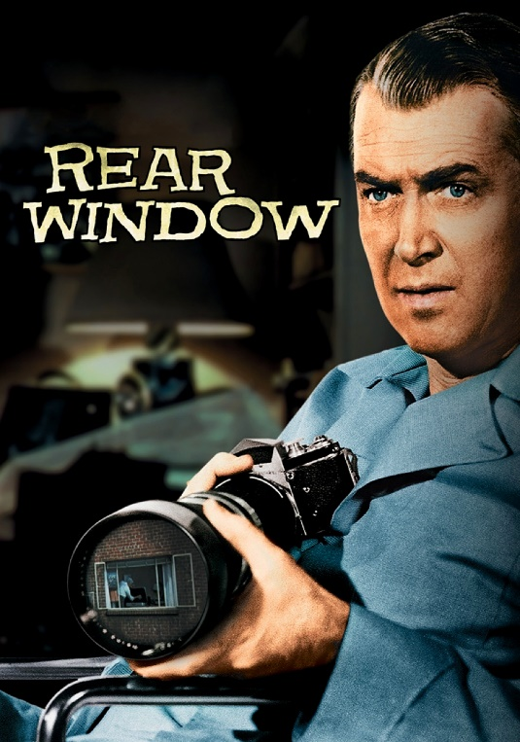

**FOUR OSCAR NOMINATIONS**

Best Direction Best Writing, Screenplay Best Cinematography, Color Best Recording, Sound

**CAST:**

L.B. Jeffries (“Jeff”) - James Stewart

Lisa Freemont - Grace Kelly

Stella - Thelma Ritter

Lt. Tom Doyle - Wendell Corey

Lars Thorvald - Raymond Burr

**The Neighbors:**

Miss Torso

Miss Lonelyhearts

The Musician

The Sculptress

The childless couple with the dog

The newlyweds

The woman with the bird

The couple with the young daughter

*Rear Window* (1954)



**FOUR OSCAR NOMINATIONS**

Best Direction Best Writing, Screenplay Best Cinematography, Color Best Recording, Sound

**CAST:**

L.B. Jeffries (“Jeff”) - James Stewart

Lisa Freemont - Grace Kelly

Stella - Thelma Ritter

Lt. Tom Doyle - Wendell Corey

Lars Thorvald - Raymond Burr

**The Neighbors:**

Miss Torso

Miss Lonelyhearts

The Musician

The Sculptress

The childless couple with the dog

The newlyweds

The woman with the bird

The couple with the young daughter